NAME: Aaditya Pal

CLASS: FYBsc. IT

ROLL NO: A031

ASSIGNMENT TOPIC: Case study on Linux, Windows and Android

SUBJECT: Operating system

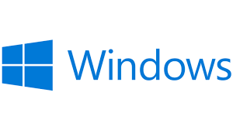

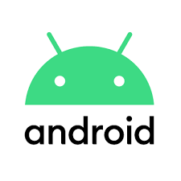

**CASE STUDY ON LINUX**

HISTORY

* LINUX is a family of open-source Unix-like operating systems based on the Linux kernel.
* It was developed by Linus Torvalds and was first released on September 17,1991.
* Torvalds began the development of the Linux kernel on MINIX and applications written for MINIX were also used on Linux. Later, Linux matured and further Linux kernel development took place on Linux systems.
* It was initially named "**Freax**”.

FEEATURES

* The major factor that helps Linux standout is that the Linux kernel and other components are free and open-source software.
* The Linux kernel is a widely ported operating system kernel, available for devices ranging from mobile phones to supercomputers.
* Most programming languages support Linux either directly or through third-party community based ports.
* Due to its low cost and ease of customization, Linux is often used in embedded systems.

 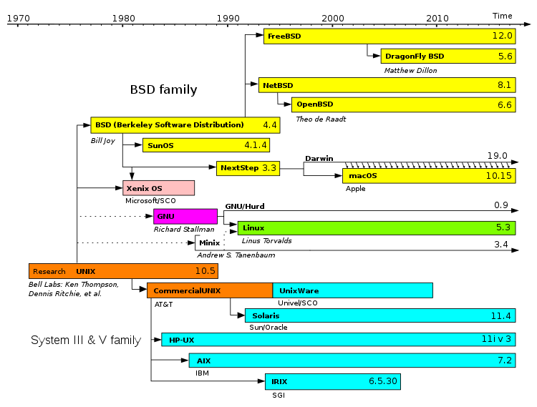

**Linus Torvalds**

**CASE STUDY ON ANDROID**

HISTORY

* Android Inc. was founded in Palo Alto, California, in October 2003 by Andy Rubin, Rich Miner, Nick Sears, and Chris White.
* It is a mobile operating system based on a modified version of the Linux kernel and other open source software, designed primarily for touchscreen mobile devices such as smartphones and tablets.
* It was unveiled in November 2007, with the first commercial Android device, the HTC Dream, being launched in September 2008.
* The early intentions of the company were to develop an advanced operating system for digital cameras.

FEATURES

* Android's default user interface is mainly based on direct manipulation, using touch inputs that loosely correspond to real-world actions, like swiping, tapping, pinching, and reverse pinching to manipulate on-screen objects, along with a virtual keyboard.
* The response to user input is designed to be immediate and provides a fluid touch interface, often using the vibration capabilities of the device to provide haptic feedback to the user.
* It is massively popular due to the services provided by which come built-in.
* Over the course of time, the devices which use android are cheaper as compared to the competition and provide more flexibility and control.

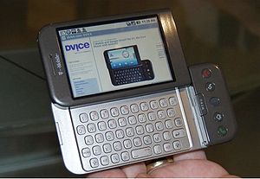

The HTC DREAM was the first commercially available android device.

**CASE STUDY ON WINDOWS**

HISTORY

* The history of Windows dates back to 1981 when Microsoft started work on a program called "Interface Manager". It was announced in November 1983 under the name "Windows", but Windows 1.0 was not released until November 1985.
* Microsoft Windows, commonly referred to as Windows, is a group of several proprietary graphical operating system families, all of which are developed and marketed by Microsoft.
* It was introduced as an operating environment on November 20, 1985, as a graphical operating system shell for MS-DOS in response to the growing interest in graphical user interfaces (GUIs).

DIFFERENT VERSIONS AND THEIR FEATURES

Windows 1.0

* Windows 1.0 is not a complete operating system; rather, it extends MS-DOS.
* Components included Calculator, Calendar, Cardfile, Clipboard Viewer, Clock, Control Panel, Notepad, Paint, Reversi, Terminal and Write.
* Windows 1.0 does not allow overlapping windows. Instead all windows are tiled. Only modal dialog boxes may appear over other windows.

Windows 2.0

* Windows 2.0 was released in December 1987, and was more popular than its predecessor.
* It features several improvements to the user interface and memory management.
* Windows 2.03 changed the OS from tiled windows to overlapping windows.

Windows 3.0

* Windows 3.0, released in 1990, improved the design, mostly because of virtual memory and loadable virtual device drivers (VxDs) that allow Windows to share arbitrary devices between multi-tasked DOS applications.

Windows 9x

* The next major consumer-oriented release of Windows, Windows 95, was released on August 24, 1995. While still remaining MS-DOS-based, Windows 95 introduced support for native 32-bit applications, plug and play hardware, preemptive multitasking, long file names of up to 255 characters, and provided increased stability over its predecessors.
* Windows 95 also introduced a redesigned, object oriented user interface, replacing the previous Program Manager with the Start menu, taskbar, and Windows Explorer shell.

Windows NT/XP

* The next major version of Windows NT, Windows XP, was released on October 25, 2001. The introduction of Windows XP aimed to unify the consumer-oriented Windows 9x series with the architecture introduced by Windows NT. Windows XP would also introduce a redesigned user interface, streamlined multimedia and networking features, Internet Explorer 6,etc.

Windows Vista

* Windows Vista was released on November 30, 2006.
* It contained a number of new features, from a redesigned shell and user interface to significant technical changes, with a particular focus on security features.

Windows 7

* On July 22, 2009, Windows 7 was released.
* Windows 7 has multi-touch support, a redesigned Windows shell with an updated taskbar with revealable jump lists that contain shortcuts to files frequently used with specific applications and shortcuts to tasks within the application.
* A home networking system called HomeGroup was introduced and performance improvements were made.

Windows 8

* Windows 8, the successor to Windows 7, was released generally on October 26, 2012.
* The changes include the Start screen, which uses large tiles that are more convenient for touch interactions and allow for the display of continually updated information, and a new class of apps which are designed primarily for use on touch-based devices.And some cloud services and removal of start menu in 8.1.

Windows 10

* On September 30, 2014, Microsoft announced Windows 10 as the successor to Windows 8.1.
* Changes on PC include the return of the Start Menu, a virtual desktop system, and the ability to run Windows Store apps within windows on the desktop rather than in full-screen mode.

Windows 11

* On June 24, 2021, Windows 11 was announced as the successor to Windows 10 during a livestream. The new operating system was designed to be more user-friendly and understandable.
* It was released on October 5, 2021.Windows 11 will be a free upgrade to all Windows 10 users.

